# Kubernetes – Node

Nodes are the Worker machines where the actual work happens. Each node has the services required to execute Pods and is controlled by the Control Plane. Each Node can have multiple pods and pods have containers running inside them. There are 3 processes in every Node that are used to Schedule and manage those pods.

1. **Container runtime:**A container runtime is needed to run the application containers running on pods inside a pod. Example-> Docker
2. **kubelet:**kubelet interacts with both the container runtime as well as the Node. It is the process responsible for starting a pod with a container inside.
3. **kube-proxy:**It is the process responsible for forwarding the request from Services to the pods. It has intelligent logic to forward the request to the right pod in the worker node.

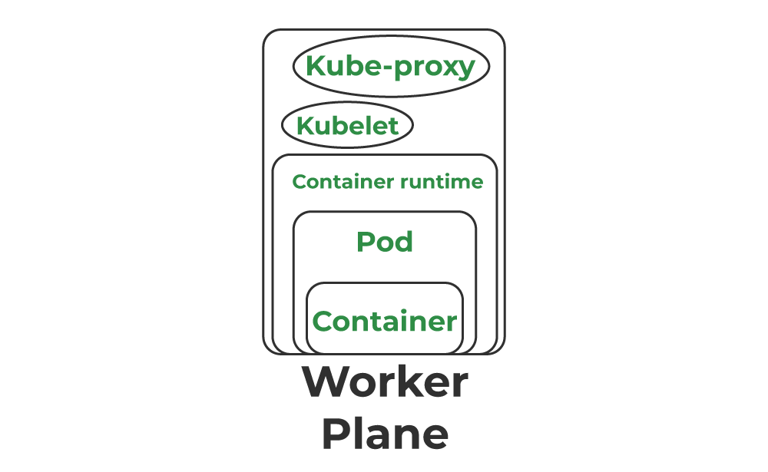

### Node Status:

To view a Node’s status and other information, use kubectl:

$ kubectl describe node <node-name>

